**IT23320482**

**N.H.A.R.Rashmindi**

**Lab 05**

**1.**

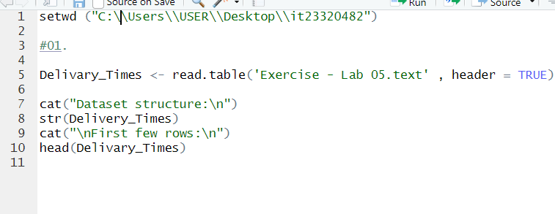

**2.**

**3.**

**4.**

